Random Forest (Class/Reg.), XGB (Class/Reg.)

Tuning the model:

Overall Result:

|  | XGB Classifier | RF Classifier | XGB Regressor | RF Regressor |
| --- | --- | --- | --- | --- |
| n_estimators | 70 | 10 | 300 | 500 |
| max_depth | 5 | 4 | 4 | 10 |
| numbers of features | 131 | 11 | 591 | 81 |
| MSE / F1 score | 0.9806428 | 0.966296 | 0.3403816 | 0.529914 |
| Before tuning: | 0.9661987 | 0.957926 | 0.3470637 | 0.364716 |

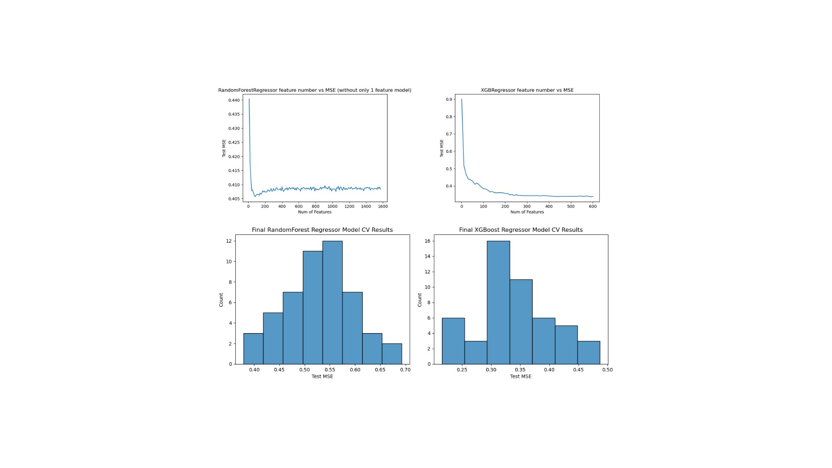

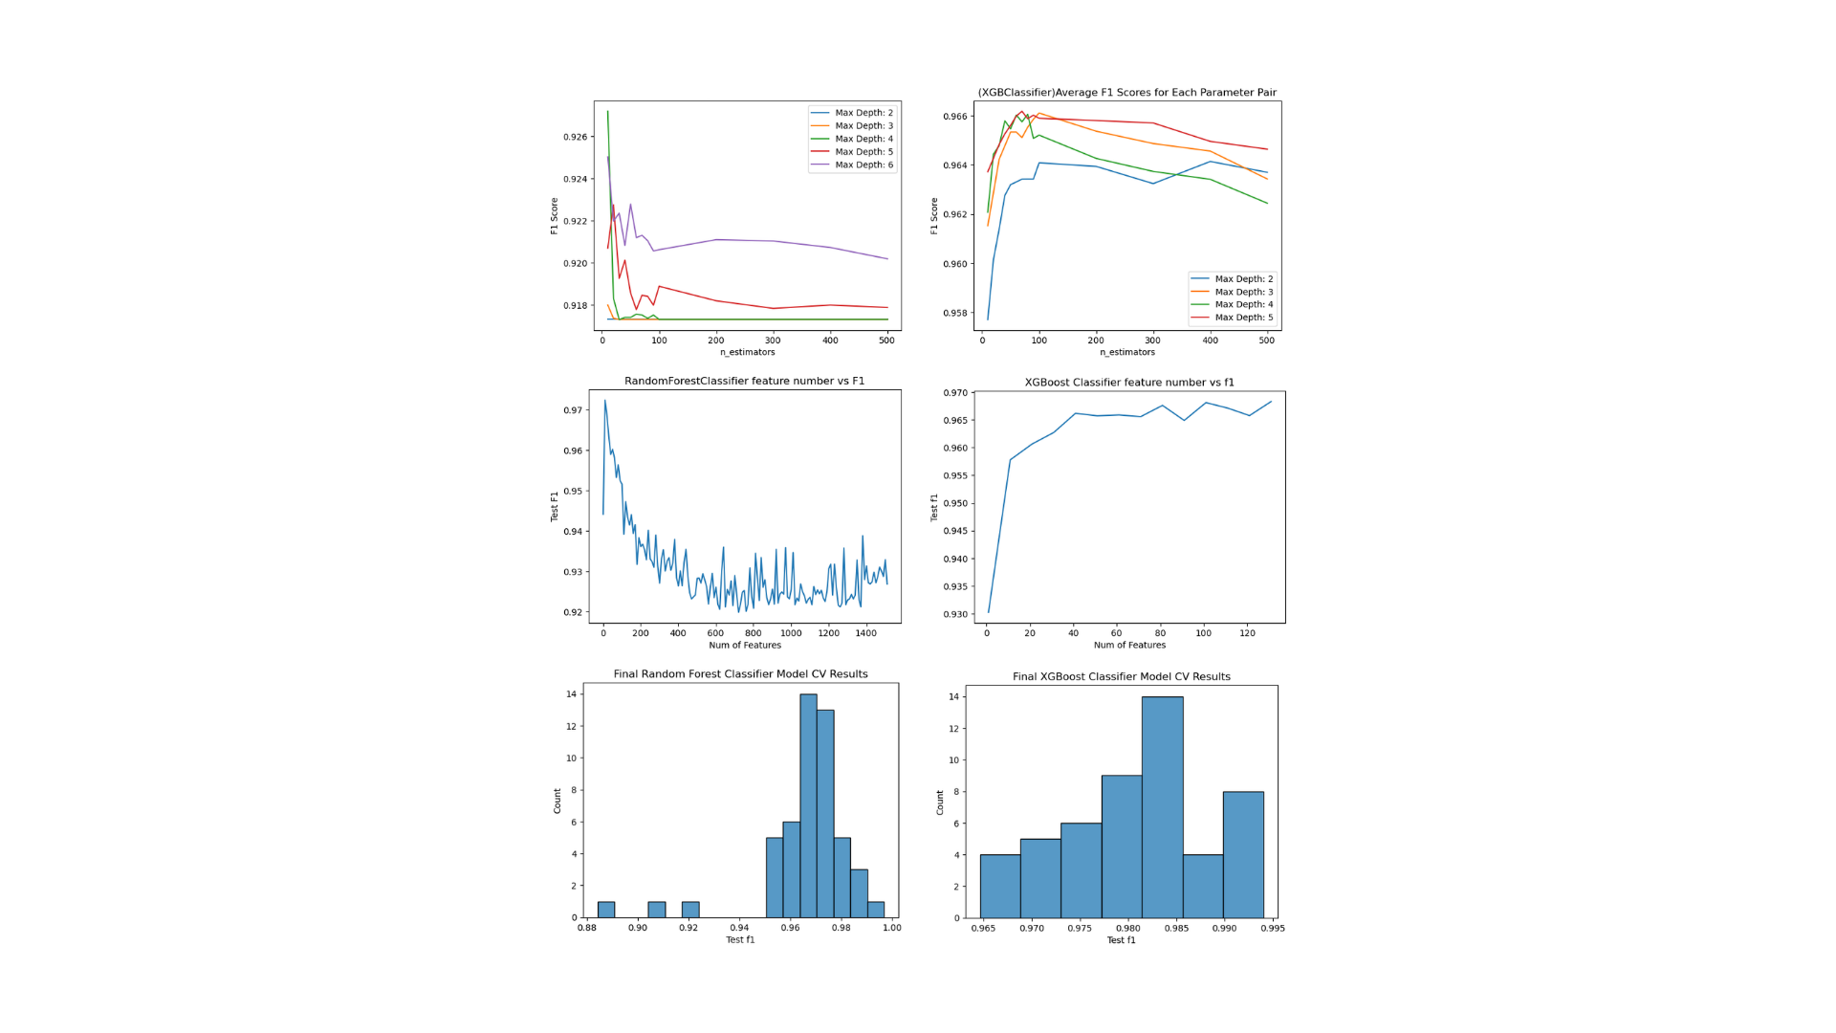

Before any tuning:

|  |  |
| --- | --- |
|  |  |